US M&O Surface Image Engineering
Build and Deploy Guide

Prepared for
US M&O Surface team
Monday, 12 January 2015
Version 2 Final
Prepared by
Steve Campbell (SOUP | MCS)
Gil Stendig
Jon Callahan

Revision and Signoff Sheet
Change Record
Date | Author | Version | Change reference
12.03.14 | Steve Campbell | 1.0 | Initial draft for review/discussion
01.04.15 | Jon Callahan / Gil Stendig | 2.0 | Updated with December 2014 patches; Office 365 and Office 2013-based Windows 8.1 WIMs, updated hardware and drivers, MDT 2013 customizations, and MS PDF Reader
01.08.2015 | Campbell | 2.1 | Hardware update, pen notes
01.08.2015 | Campbell | 2.11 | Updated contact info
Reviewers
Name | Version approved | Position | Date
Gil Stendig | 1.0
Jon Callahan | 1.0

Table of Contents
1 Surface 3 deployment 1
1.1 Overview and Approach 1
1.2 Prepare/Verify Environment 1
1.3 Requirements 1
1.4 Deployment Media Preparation 1
1.5 MDT Media 1
1.6 USB Stick (Windows-to-Go) 2
1.6.1 Prepare USB WTG stick 2
1.6.2 Populating the USB WTG stick 2
1.7 USB HDD 3
1.7.1 Prepare USB HDD 3
1.7.2 Populating the USB HDD 3
1.8 Installation (OS Deployment) 4
2 Next Steps 10
3 Details and Build Notes 11
3.1 Image Contents (WIM) 11
3.2 Image Deployment 12
4 Glossary 12
5 References 13
6 BUILDING YOUR OWN SOLUTION 14
6.1 General MDT Image and Deploy Instructions 14
6.1.1 Download and install the Microsoft Deployment Toolkit (MDT) 14
6.2 Detailed Guidance 14

- Surface 3 deployment
  - Overview and Approach
The implementation within this guide essentially follows the detailed guidance provided in the “Deployment and Administration Guide for Surface Pro 3”. For further details and customization please download from http://www.microsoft.com/en-us/download/details.aspx?id=45292
FOR ANY QUESTIONS ON THIS DOCUMENT OR THE RELATED DEPLOYMENT SOLUTION …. PLEASE CONTACT: SurfaceBlackbelts@microsoft.com
  - Prepare/Verify Environment
  - Requirements
To perform the build you’ll need a couple of components.
- Surface Pro 3 tablet/computer
- Surface Pro 3 power adapter
- USB UEFI bootable media stick or USB HDD
- Optional - Surface Pro 3 dock
- Optional – Surface Pro 3 pen
- Optional – Surface Pro 3 network dongle
- Optional – Surface Pro 3 HDMI or other video adapter
- Optional – USB/Network adapter
The solution has been tested successfully with the components in BOLD.
  - Deployment Media Preparation
The US EPG Surface Image Deployment Service is based upon a USB media delivery approach. Customers and OS deployment technicians can utilize either US hard disk drives or specialty USB sticks. Due to the UEFI boot environment for Microsoft Surfaces a FAT32 bootable USB stick is required.
  - MDT Media
MDT 2013 creates media deployment folders that can be used in a variety of delivery approaches –in our case a Media deployment point is a USB device. The structure will look like this. All of the content we need to boot and re-image Surface devices will come from this MDT file and folder structure.
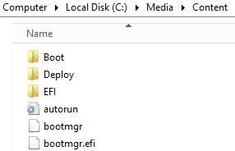
For the rest of this document, our SOURCE content will live at C:\CONTENT
  - USB Stick (Windows-to-Go)
The customized and patched Surface Pro 3 image is over 5GB in size and therefore won’t fit on a FAT32 partition – this necessitates the specialty USB stick. A Windows-to-Go certified USB stick which identifies as a fixed disk is required and recommended. Testing was done with a DataTraveler 32GB Workspace stick.
The following instructions must be followed to partition, format and populate a USB WTG stick:
    - Prepare USB WTG stick
- Verify if the drive is reporting itself as fixed or removable plug the drive in and open My Computer:
  - Drive shows up under “Hard Disk Drives”: Fixed
  - Drive shows up under “Devices with Removable Storage”: Removable
- Open an elevated command prompt
- Type in diskpart and hit enter
- Enter the following commands
  - List disk
  - Sel disk X: (where X: is your USB drive, make sure it’s not Disk 0)
  - Clean
  - Create Part Primary size=2048
  - Assign
  - Active
  - Format fs=fat32 quick Label=”Boot”
  - Create part primary
  - Assign
  - Format fs=ntfs quick Label=”Deploy”
  - Exit
    - Populating the USB WTG stick
After locating the correct drive and preparing it you must use the following steps to copy the MDT media deployment files to it. After preparing the USB WTG stick
- Assuming your media deployment is located at C:\Content (or elsewhere)
- Assuming the FAT32 partition has volume label of BOOT
- Assuming The NTFS partition has volume label of DEPLOY
- Assuming deploying Windows 8.x to Surface Pro devices
- Copy files to BOOT drive(FAT32)
  - Copy c:\media\content\boot folder to root of the BOOT drive
  - Copy c:\media\content\efi folder to root of the BOOT drive
  - Copy c:\media\content\autorun.inf, bootmgr, bootmgr.efi to root of the BOOT drive
  - Create a Deploy folder in root of the BOOT drive
  - Copy c:\media\content\deploy\boot to Deploy folder in the BOOT drive
- Copy files to DEPLOY driver (NTFS)
  - Copy c:\media\content\deploy folder to root of the DEPLOY drive
Remove the device, insert in to a Surface Pro and boot the systems holding the Volume button down.
  - USB HDD
Instead of a USB WTG stick, a standard USB hard disk drive (HDD) can be used. USB 2.0 or 3.0 should work ok, but USB 3.0 will provide higher throughput. This device too must be dual formatted for FAT32 and NFTS.
    - Prepare USB HDD
- Verify if the drive is reporting itself as fixed or removable, plug the drive in and open My Computer:
  - Drive shows up under “Hard Disk Drives”: Fixed
  - Drive shows up under “Devices with Removable Storage”: Removable
- Open an elevated command prompt
- Type in diskpart and hit enter
- Enter the following commands
  - List disk
  - Sel disk X: (where X: is your USB drive, make sure it’s not Disk 0)
  - Clean
  - Create Part Primary size=2048
  - Assign
  - Active
  - Format fs=fat32 quick Label=”Boot”
  - Create part primary
  - Assign
  - Format fs=ntfs quick Label=”Deploy”
  - Exit
    - Populating the USB HDD
After preparing the USB disk driver
- Assuming your media deployment is located at C:\Media\Content (or elsewhere)
- Assuming the FAT32 partition has volume label of BOOT
- Assuming deploying Windows 8.x to Surface Pro devices
- Copy files to BOOT drive(FAT32)
  - Copy c:\media\content\boot folder to root of the BOOT drive
  - Copy c:\media\content\efi folder to root of the BOOT drive
  - Copy c:\media\content\autorun.inf, bootmgr, bootmgr.efi to root of the BOOT drive
  - Create a Deploy folder in root of the BOOT drive
  - Copy c:\media\content\deploy\boot to Deploy folder in the BOOT drive
- Copy files to DEPLOY driver (NTFS)
  - Copy c:\media\content\deploy folder to root of the DEPLOY drive
Remove the device, insert in to a Surface Pro and boot the systems holding the Volume button down.
  - Installation (OS Deployment)
The installation (or re-imaging) process is relatively straightforward. Users or technicians need to boot to a USB device and complete a few simple wizard screens to rebuild a Surface Pro.
WARNING: All data will be destroy. No applications, data, configuration or encryption will be migrated.
ATTENTION: The Surface Pro 3 should be connected to AC power during the deployment process.
ATTENTION: Do not disconnect the USB drive until the system returns to a User Logon screen.
REQUIREMENTS:
- Surface Pro 3 (i3, i5, i7)
- Surface Pro 3 keyboard
- Network adapter or dongle or dock (if domain joining)
- Surface Pro 3 pen (optional)
- Surface Pro 3 dock (optional, recommended if domain joining)
- USB bootable media with EPG Surface Pro 3 deployment solution
- KMS (Key Management Server) or MAK key for Windows and Office activation (can be provided after deployment)
- Verify that the Surface Pro 3 is shutdown.
- Attach one of the previously created and populated bootable USB devices to the Surface Pro 3 USB port.
- Press and hold the volume-down button.
- Simultaneously, Press and release the power button.
- When the Surface logo appears, release the volume-down button.
- Select  Start the Surface Deployment. | 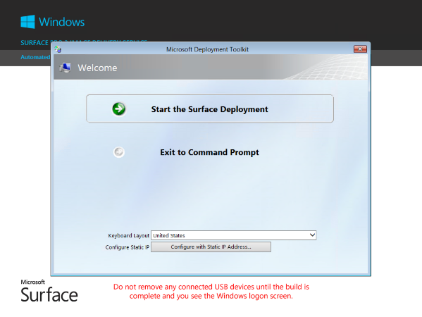
- Select the appropriate Task Sequence to deploy Windows 8.1 and Office versions desired. | 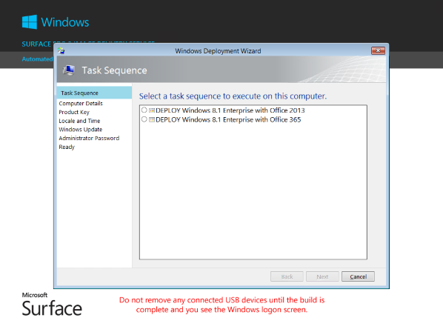
- Enter the computer name and details to join either an Active Directory domain or Windows workgroup.  If you choose to join a domain you must also provide the domain name and the username/password for an account with permissions to join the domain.  NOTE: Joining an Active Directory domain requires an active network connection during the deployment. Wireless network connectivity is not available at this stage so it is necessary to connect to the network using either an Ethernet USB adaptor or docking station.  If using an Ethernet USB adaptor, you will need to attach a USB hub to the Surface Pro 3 and then connect your bootable USB device and Ethernet USB adaptor (or use a Surface Pro 3 dock) | 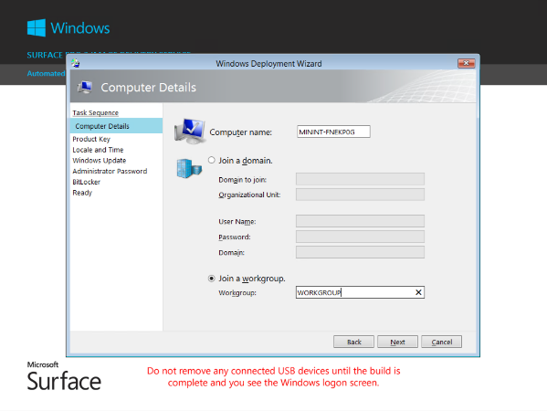
- Specify the product key to use for Windows Activation.  NOTE: If using KMS volume activation you should choose No product key is required. The deployment is automatically configured for KMS activation.  If using MAK volume activation or another product key specific key, such as a retail key, choose the appropriate option. | 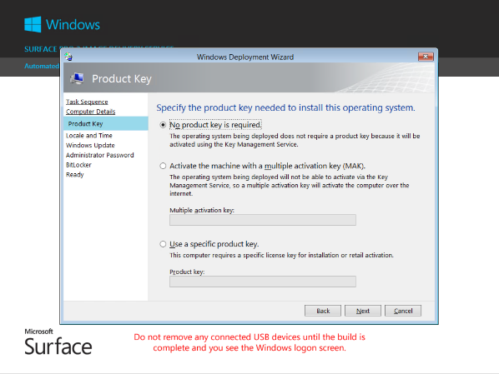
- Choose your preferred language, keyboard, and time zone options. | 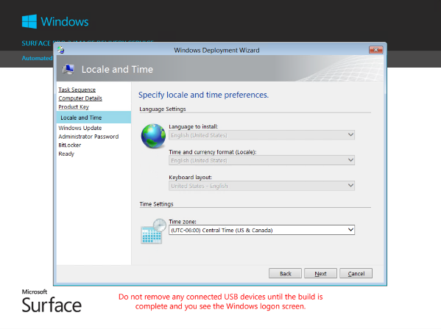
- Select whether to run Windows Update or not during the deployment.  Run Windows Update will install all available updates over the Internet from Microsoft Update for Windows, Office, and other installed Microsoft products.  Run Windows Update using WSUS will install targeted updates from an internal Windows Server Update Services (WSUS) server. Type the URL to the WSUS server in the WSUS Server URL input box. Note that you must have WSUS setup and configured to use this option.  Do not run Windows Update will not install any updates during the deployment. | 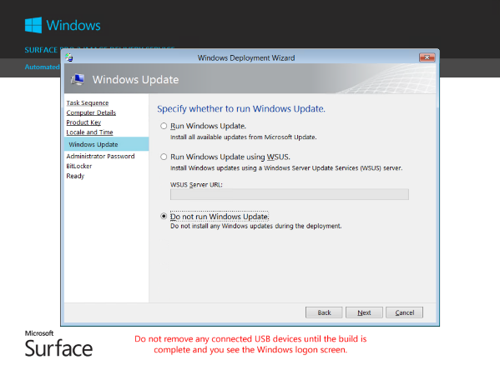
- Specify the password of the local Administrator account.  You must specify an administrator password.  You will need to add additional user accounts later manually | 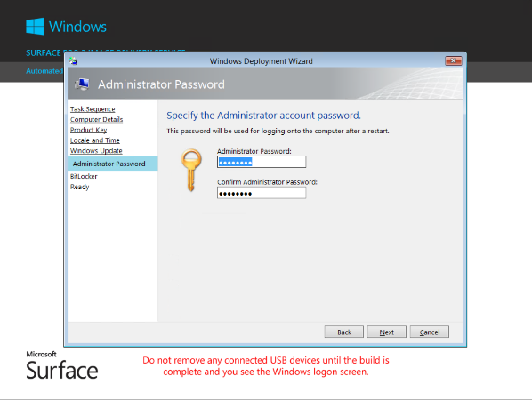
- Choose whether or not to enable BitLocker drive encryption.  If you choose to not enable BitLocker then the drive will not be encrypted.  If you choose to enable BitLocker then you must select the protector type and where to save the BitLocker recovery key, for example to Active Directory. It is not recommended to enable BitLocker and not backup the key.  For more information on BitLocker: http://technet.microsoft.com/en-us/library/hh831713.aspx | 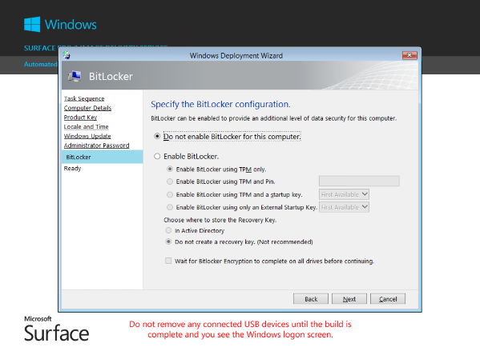
- Review the deployment details and then click Begin to start the deployment. | 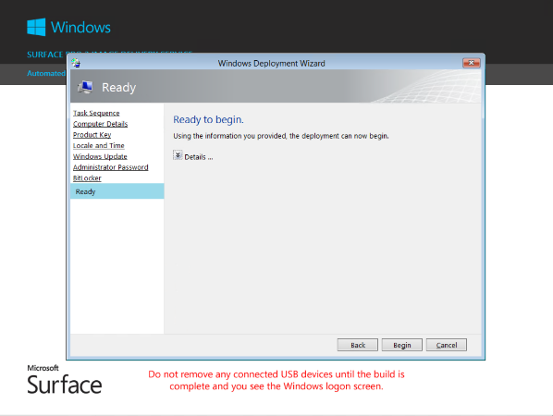
- The deployment will now install the Windows image.  No further steps are needed on this action. | 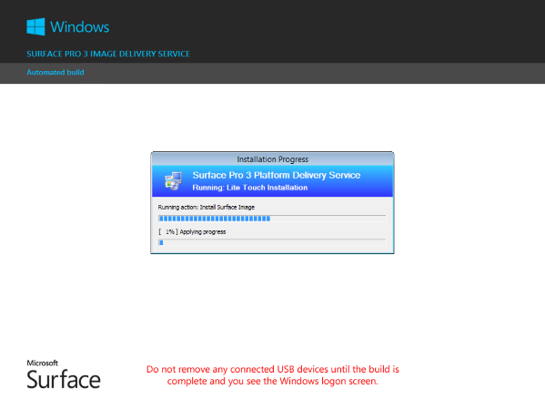
The deployment is complete once the Windows logon screen is displayed.  You may now remove the bootable USB device and logon to Windows. | 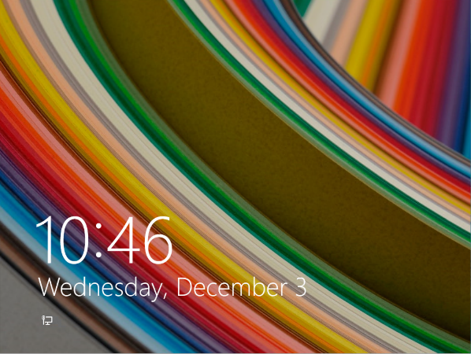
There may be additional Updates to install for the device based on when you receive this image.  1. Swipe in from the right and select “Settings”  2. Select “Change PC Settings”  3. Select “Update and recovery”  4. Select “Check now” to check for any additional updates.  5. Select “Install” for all selected updates | 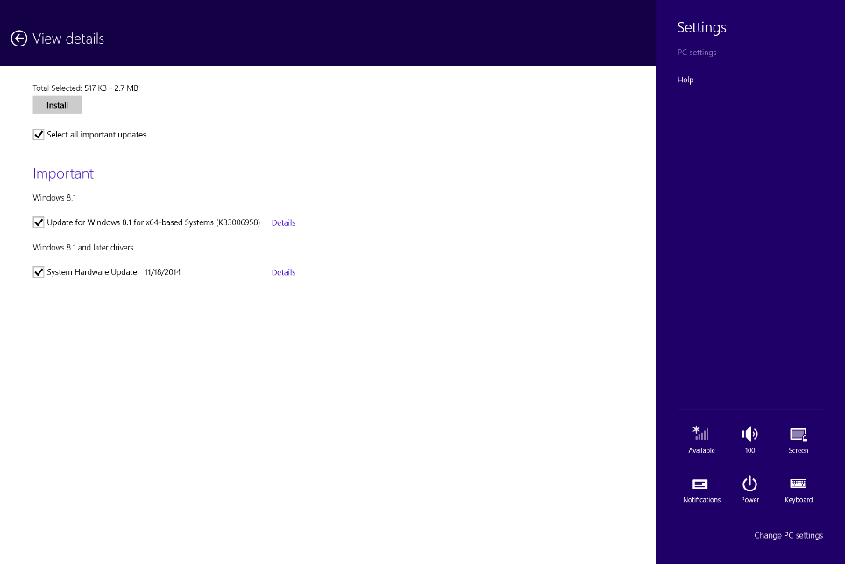

- Next Steps
So you’ve just reimaged your new Microsoft Surface Pro 3 device…. What now? What else should you do to begin fully enjoying this great bit of technology? While you can certainly use it as-is just after imaging there’s a few things most users and IT shops will want to do
- MAIL and Productivity
  - Configure Microsoft Mail (for your Exchange, Office 365, or other accounts like Outlook.com, Hotmail, and more)
  - Configure Outlook 2013 or Outlook 365 for your corporate mail
  - Customize your start menu
    - Shrink, expand, group applications
  - Enable and use OneDrive (Personal)
  - Enable and use OneDrive for Business (enterprise)
  - Move Or copy work files and personal files to Cloud storage (OneDrive)
  - Change Files Save defaults to OneDrive
- SURFACE PEN – Pair your Surface Pro 3 Pen
  - See detailed instructions at https://www.microsoft.com/surface/en-us/support/touch-mouse-and-search/surface-pen
  - Press and hold the purple button on the top of the pen until a green light is illuminated under the pen’s clip
  - PC Settings -> PC and devices -> Bluetooth
  - Tap the Surface Pen in the devices list and pair the device
- PATCHES -Install the latest patches and updates
  - Attach all of your peripherals, insert your Surface in its dock
  - Even though we’ve provided a build that is nearly up-to-date, some patches and new drivers may have shipped since we last updated the solution.
  - PC Settings -> Update and Recovery
    - Enable the tick box for Check for updates from Microsoft Update (if you domain joined)
    - Click on Choose how updates get installed
    - Select both the Recommend Updates and Microsoft Update options
    - Got back go the main Windows Updates screen and click Check Now
    - Enable all of the available updates and driver packages
    - Update and accept all updates
  - Reboot as recommended
- SETTINGS – Adjust PC Settings
  - Set the time zone to your local time zone
  - Make sure the time is correct and auto adjusted(time internet)
  - PC Settings -> Time and Language -> Date and Time
- DOMAIN JOIN - If you ‘ve not already done so… join it to your corporate domain
- USER ACCOUNTS – create a local account or enable your domain account
  - Add a domain user as a standard user or admin user to the surface
  - Create a new local account
  - Connect a new local account to your Microsoft ID
  - Disable the administrator account (only if you’ve created another admin or joined to domain)
- INSTALL PERIPHERALS
  - Install printers
  - Detect Devices
  - Connect your Bluetooth devices
- NETWORK – attach your surface to wired or wireless networks
  - Connect to wireless or wired networks
  - Connect to network devices
  - Make your device discoverable on the network
- APPLICATIONS – install applications for work or for play
  - Swipe down
  - Browse the store
  - Install the Company Portal
  - Install apps from your company repository, SCCM or DVD
  - What kinds of apps?
    - Adobe Flash, Shockwave
    - Java
    - Social apps like Facebook, Twitter, Instagram
- EXPAND delivery – add your image and Deploy TS to deployment solution
  - PXE enabled deployments using Windows Deployment Services (WDS)
Eliminates the need for USB sticks

- Details and Build Notes
  - Image Contents (WIM)
The image was built using MDT 2013 and the associated ADK using a Hyper-V build environment. Deployment and testing was done using physical Surface units.
- Operating System
  - Windows 8.1 Enterprise, 64-bit
  - English only
  - Volume License media (requires activation by KMS or MAK)
- Office
  - Office 2013 Enterprise , 32-bit
  - Option for deployment of MSI installation (full not pre-cached) or C2R/O365 version
  - English only
  - Volume License media (requires activation by KMS or MAK)
  - All tools installed
- Customizations
  - Silverlight installed
  - Stock “modern” apps removed (e.g. Weather, Stocks, etc.), except MS PDF Reader, People, Calendar, Mail, Bing Maps, and Skype
  - Internet Explorer pinned to taskbar
  - Sample music/pics/videos removed from system
  - Stock start screen
  - Smaller SXS component directory (thanks to some clean-up magic, courtesy of Niehaus)
  - Added Microsoft PDF Reader to add ability to view PDF files
- Patches
  - All patches as of (and including) December 2014
  - Includes the Win 8.1 Nov 2014 Cumulative Rollup that was just released, as well as Office 2013 SP1
  - Additional patches recently released and applicable
  - Image Deployment
The image is deployed using customized MDT 2013 offline media. Customizations include:
- Support for deploying multiple Windows 8.1 images
- Surface Pro 3 firmware and drivers
  - Surface Pro 3 Pen
  - Surface Pro 3 Docking Station
  - Surface Network Adaptor
- Hardware validation for Surface Pro 3
- Notification if running on battery power during deployment
- Surface Pro 3 power and hibernation optimizations
- Customized Windows PE background and MDT Wizard for Surface
- Windows Update opt-in pane for MDT Wizard
- Default Surface Pro 3 Pen to desktop OneNote
- Glossary
MDT – Microsoft Deployment Toolkit
ADK – Windows Assessment and Deployment Kit
WIM – Windows Image
OSD – Operating System Deployment
- References
- UEFI Media from MDT for Surfaces
http://blogs.technet.com/b/askcore/archive/2013/04/02/microsoft-deployment-toolkit-2012-update1-media-deployment-usb-drive-for-uefi-computer.aspx
- UEFI Boot devices
http://blogs.technet.com/b/supportingwindows/archive/2013/03/20/creating-bootable-usb-drive-for-uefi-computers.aspx

- BUILDING YOUR OWN SOLUTION
The following high level steps can be implemented to “roll your own” MDT Imaging and Deployment Solution. For more details –
  - General MDT Image and Deploy Instructions
    - Download and install the Microsoft Deployment Toolkit (MDT)
  - Generally you want the most recent version and/or the version that supports the OS you’re attempting to build and deploy
  - Install the version for the OS YOU ARE WORKING ON
(e.g. if the box you’re installing MDT on is running 64-bit OS, install 64-bit MDT
  - In this Case -> MDT 2013.
- Download and install the Windows Assessment and Deployment Toolkit (ADK)
  - ADK is the “command lines and build time tools”
  - MDT is the “graphical and deploy time tools”
- In MDT (BUILD)
  - Create a new MDT Deployment Share – this holds on the image BUILD parts
  - Import a new OS – Windows 8
  - Import a new app – Office for example
  - Add a new App to the BUILD TS in the State Restore section of the TS
  - Import Surface drivers –
  - Create a BUILD and capture Task Sequence
  - Configure and create BOOT media
  - Create and test image using MDT and HyperV
  - Create and capture the custom image as DEPLOY.WIM (or similar)
- In MDT (DEPLOY)
  - Create a new DEPLOY TS
  - Added a detection script in the drivers area to inject Surface Drivers
  - Configure CustomSettings.ini to prompt for DEPLOY wizards
  - Create an MDT Media Deployment Point
  - Share the contents of MDT Media deployment point (or use ISO, etc)
  - Detailed Guidance
- Deployment and Administration Guide for Surface Pro 3
http://www.microsoft.com/en-us/download/details.aspx?id=45292
- Deployment Guys Blog
http://blogs.technet.com/b/deploymentguys
https://www.facebook.com/pages/DeploymentGuys/123357137739965
- Desktop Image Management: Build a Better Desktop Image
http://technet.microsoft.com/en-us/magazine/ff721826.aspx
- Create a Windows 8.1 Reference Image
http://technet.microsoft.com/en-us/library/dn744290.aspx
- Creating a fully-patched image using MDT 2010 Lite Touch
http://blogs.technet.com/b/mniehaus/archive/2011/05/16/creating-a-fully-patched-image-using-mdt-2010-lite-touch.aspx

